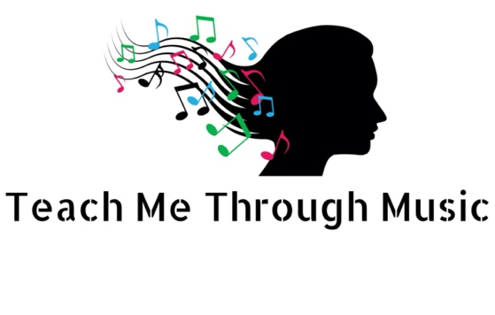
Sound Walk

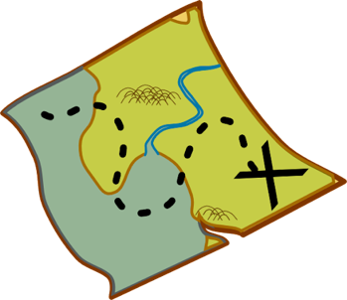
Go for a walk with your class and take notes on the sounds on your journey. You could draw these or write key words.
For Example: The sea or dogs barking

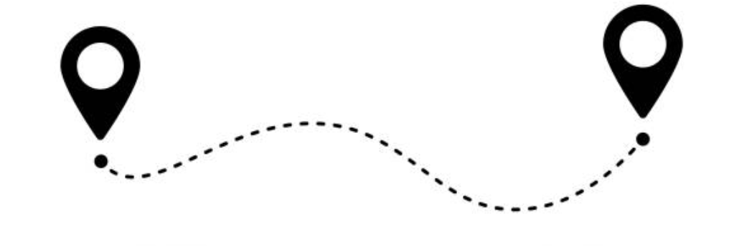

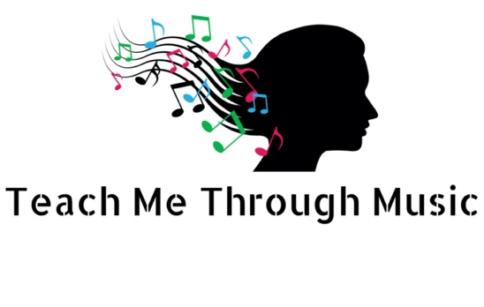

What do you think were the 3 most important sounds you heard on your sound walk?
Why do you think those sounds are important? What do they tell us about the place you walked through?

What other sounds do you think would have helped build up a picture of the place you visited?
How can the sounds help you to learn more about the place you visited?

